Case Analysis for Detected suspected stolen user credential for user Lee Jun Yan
Account: junyan.lee @gentingplantations.com
Case Owner: Aris
Reference: InteractiveSignIns Logs and InteractiveSignIns Auth Details.
Background: I reviewed 30 days Entra sign-in history for junyan.lee@gentingplantations.com and found a consistent authentication pattern associated with a managed Azure AD joined Windows device from Device ID: e2d91bfb-e9c7-4110-81c8-b1061bde9ba3 and android device ID: 1cb80769-b19d-45b7-81d6-22d4cd6ab96c in usual locations of Cheras, Selangor, Malaysia.
Case Description: Found Failed Login Events with error code 50126 (AD reject wrong username and password) and 50054 (account disabled) on below dates.
- 22 Sep 2026
- 3 Sep 2026
- 26 Aug 2026
Additional Notes: Between 21 Sep 2026 11: 27am to 22 Sep 2026 11:35am user successfully sign in from different location Singapore with correct MFA authentication token but different IP 23.106.249.37. On 22 Sep 11:36am user switch back to usual Malysia location.
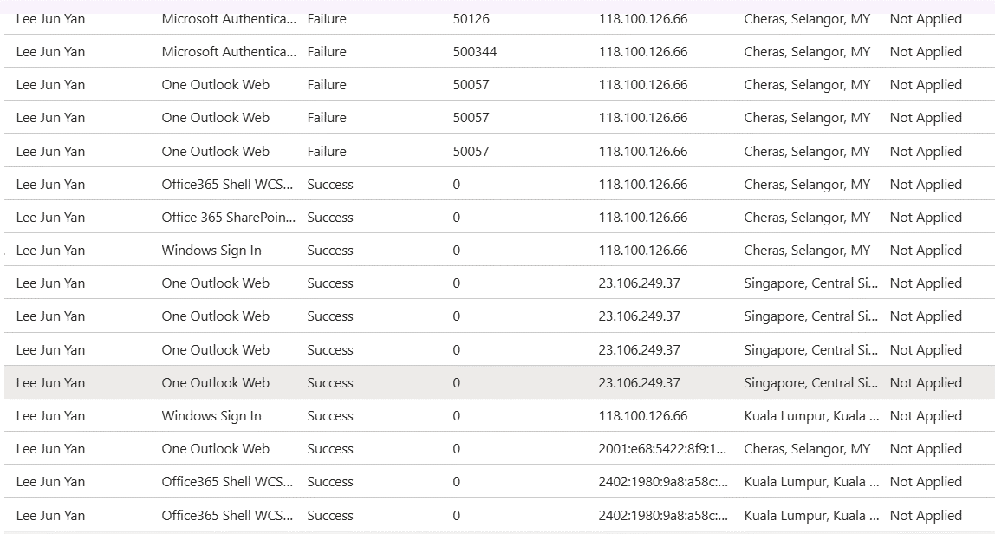
Classification: False Positive
Justification: User is likely using the VPN and no compromise have been found. The observed sign in data is consistent with users’ historical sign in data and now sign in back with same device ID: e2d91bfb-e9c7-4110-81c8-b1061bde9ba3
Suspected IP is 98% Clean
